2023 NBLC CHRISTMAS PARTY COMPETITION

Judging
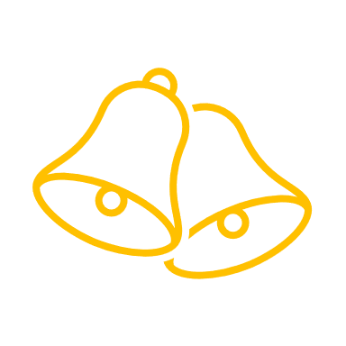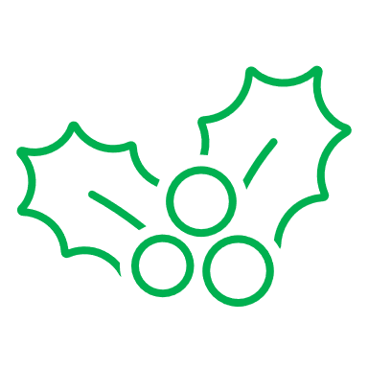
The competition will be judged by club members at the 2023 Christmas Party. It is not about the best technique but appeal and originality. Each member attending the party will be given a token to vote on their favourite entry.

Topic
Animals
Use your imagination – Cast, Engraved, Enamelled, Cabbed, Carved or Facet. Jewellery representing your pet or for your pet . Cabbed stones that look like fish. Stones with spiders made from the facets.

Material
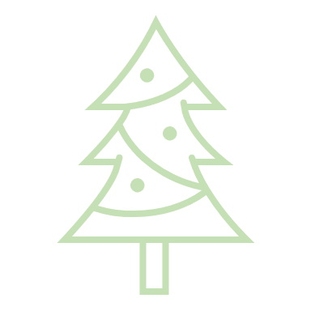 There is no restriction on materials used. 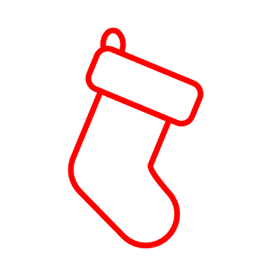

To Enter
Place the entry in the box (located on the duty officers’ desk), along with completed details below by Friday 1st December 2023
Maximum 3 entries per person

2023 Christmas Party Competition

Name ________________________________________________
Description of item and any packing materials you wish returned.

